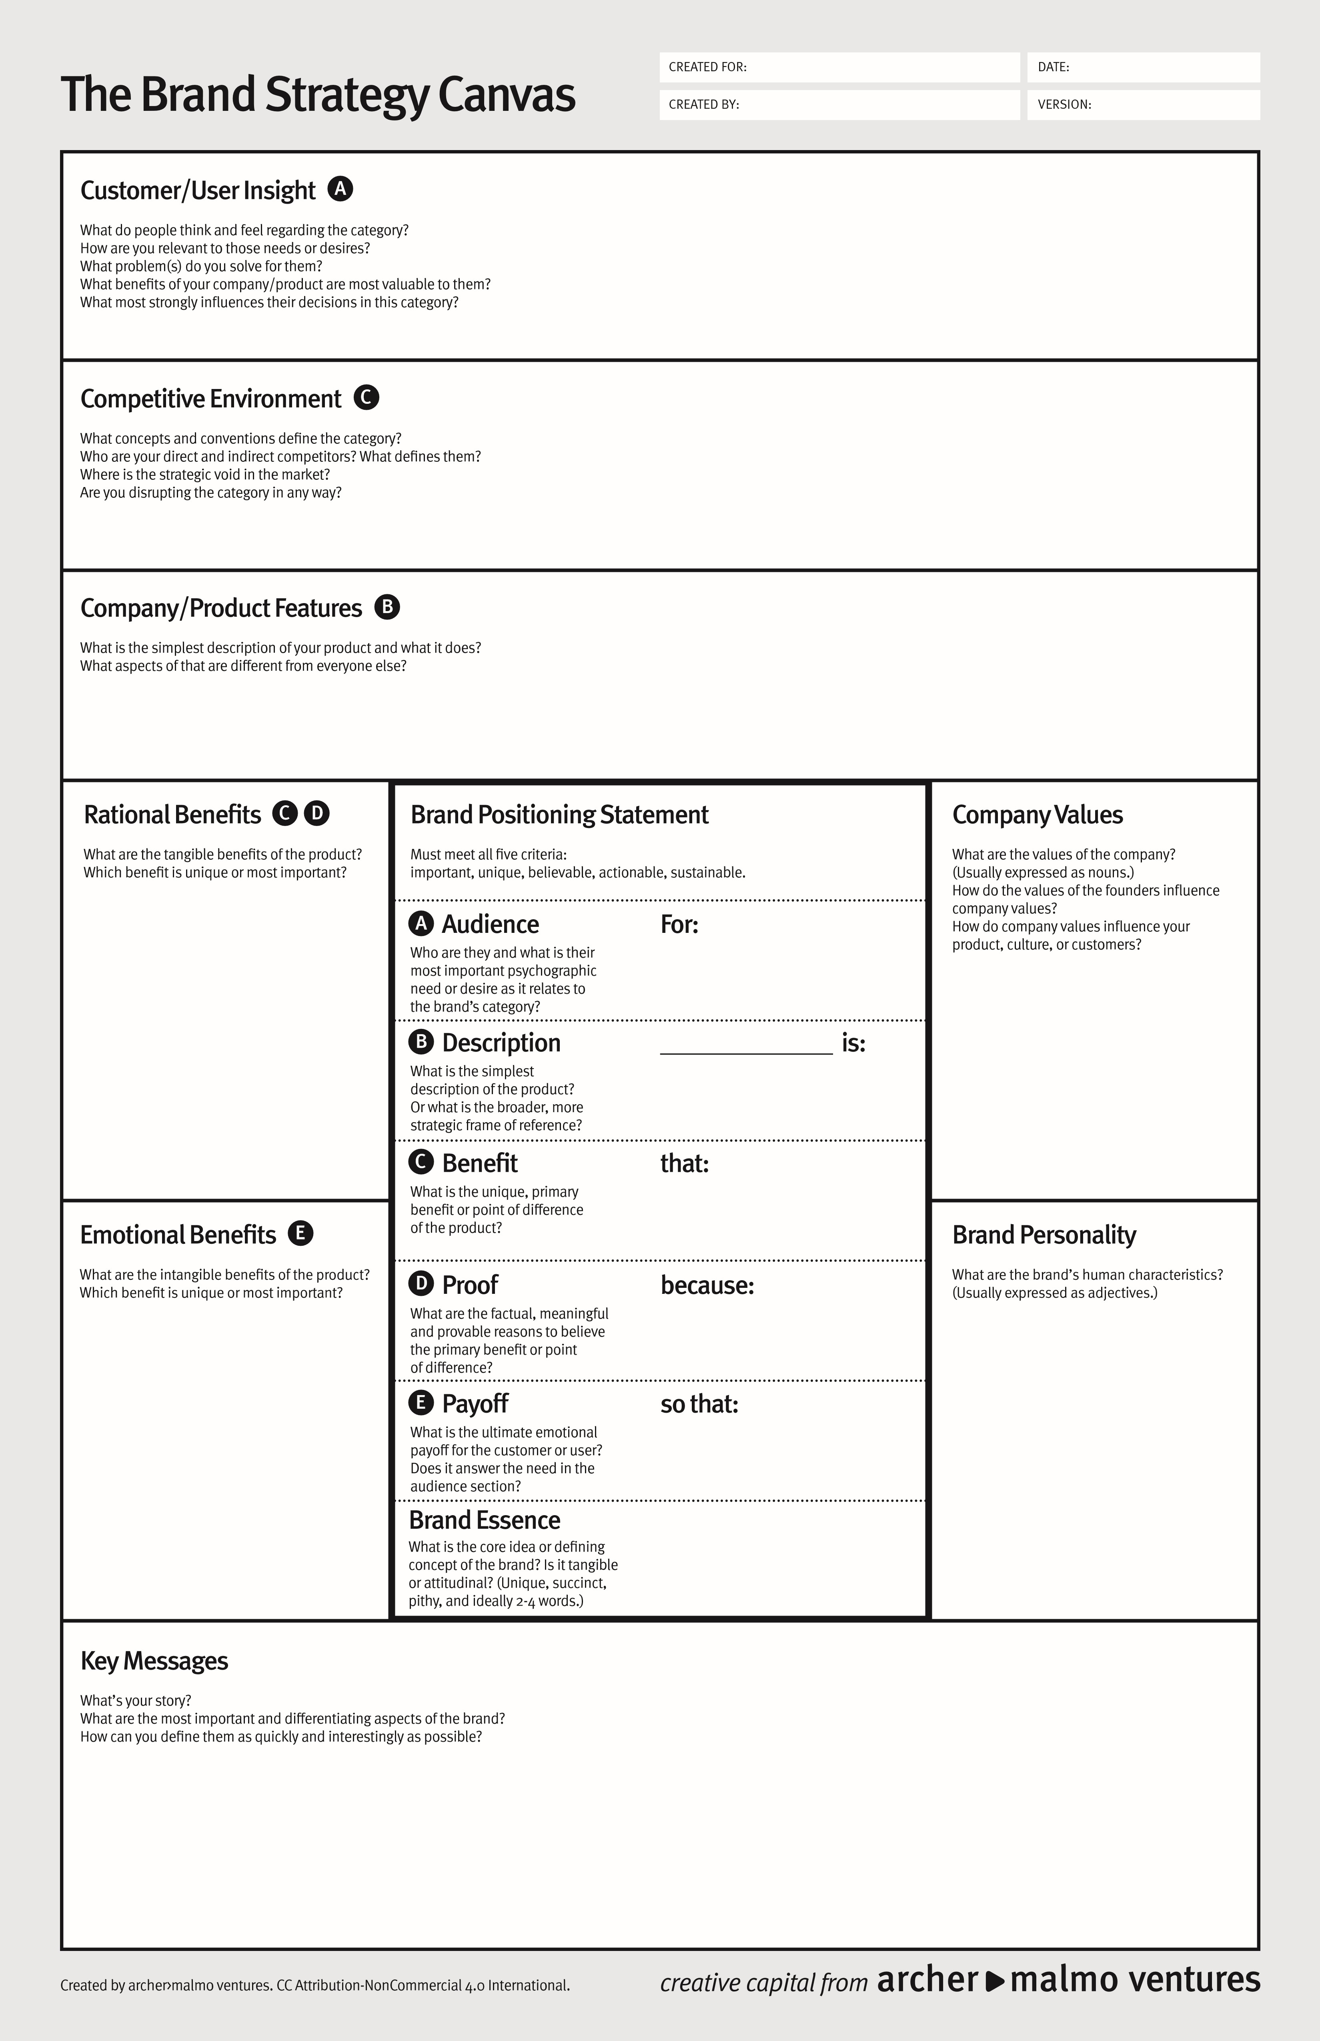
*Tangible benefits: Artists gain exposure through interviews and conversations that can be shared across platforms. Fans discover new bands and albums within metal and pop-punk. Context and storytelling deepen understanding of albums, lyrics, and scenes. Scene connection where listeners learn about festivals, tours, releases, and movements. Replayable content in video/audio form that can be clipped for social media.
*Most important unique rational benefit: Kyywayy’s Music Hotspot provides emotionally intelligent, genre-specific interviews that spotlight artists who might not get any serious conversational coverage elsewhere.

Core values:
- Originality
- Empathy
- Representation
- Community
- Passion
- Creativity
- Respect
Founder influence:
Your personal values—caring deeply about artists, loving metal and pop-punk, prioritizing emotional honesty, and wanting underdogs to win—shape the brand’s DNA. As a “Revolutionary Empath”–type leader, you center empathy, disruption, and creativity, which naturally become the brand’s values.
Influence on product, culture, customers:
- Originality & empathy shape how you ask questions and interact with artists.
- Representation & community guide which artists you choose to feature (especially overlooked, emerging, or marginalized voices).
- Passion & creativity push you to experiment with formats (livestreams, panels, album deep dives).
- For customers, these values create a space that feels safe, emotionally rich, and aligned with their identity, building loyalty and word-of-mouth.

1. Simplest description:
Kyywayy’s Music Hotspot is a creator-led music show (podcast/video/livestream) that features interviews, album conversations, and scene-focused content about metal and pop-punk artists.
2.
What’s different:
- It is laser-focused on metal and pop-punk, not all genres.
- The tone is emotionally open, supportive, and culturally literate artists are treated as people, not content.
- It aims to platform smaller and underground artists, not just already-famous names.
- The host’s personality and lived connection to the scene are central to the brand.

1. Fans and artists in metal and pop-punk often feel that most media either ignore them or treats the genre as a stereotype. They feel that big outlets either only cover huge names or reduce heavy music to trends. They want spaces that respect their emotions, their stories, and their sound.
2. Kyywayy’s Music Hotspot is relevant because it takes their genres seriously and emotionally, offering conversations that feel like they’re coming from a fellow fan, not an outsider. You solve the problem of lack of genuine, genre-specific coverage by centering artists who are often overlooked and giving them room to speak honestly.
3. The most valuable benefits are:
- honest interviews
- culturally aware questions
- focus on smaller bands
- emotional depth vs. generic “press cycle” conversations

4. What most influences their decision to engage is whether the content feels original, emotionally real, and genre-literate. If it feels like “one of us” is hosting, they are in.

1. The category (music interviews/content) is defined by concepts like artist access, originality, personality-driven content, YouTube/TikTok presence, and community building. Common conventions include Q&A interviews, album reaction videos, commentary, and social clips.
2. Direct competitors:
- Other alternative music interview channels and podcasts
- Niche YouTube channels (e.g., Punk Rock MBA–style creators, scene-focused interviewers)
- Smaller rock/metal podcasts and IG/TikTok content creators

3. Indirect competitors:
- Larger outlets like Alternative Press, Loudwire, Kerrang!
- Spotify/Apple Music podcasts
- Social commentary accounts on TikTok/YouTube that talk about scenes and subgenres

4. The strategic void: many platforms either feel too corporate or too broad. There is space for a deeply personal, emotionally intelligent, metal+pop-punk-specific platform that’s small enough to be intimate but serious enough to be respected. Kyywayy’s Music Hotspot disrupts by combining fan-level emotional connection with intentional, thoughtful conversation, giving underrepresented artists a platform that feels safe, honest, and aligned with their community.

1. “A real voice for metal and pop-punk artists.”
Kyywayy’s Music Hotspot exists to spotlight the artists and scenes that mainstream media overlooks. The platform gives back to musicians especially upcoming and underground acts and a space to share their original stories.

2. “Where fans and artists actually feel understood.”
The brand is built by someone who genuinely lives inside these genres. This cultural fluency and emotional awareness set the tone for honest, relatable conversations that resonate deeply with fans.

3. “Original, unfiltered conversations and not scripted interviews.”
What makes the Hotspot different is the vibe: real talk, raw energy, and meaningful connection. It’s more like a backstage conversation than a promotional press interview.

4. “A discovery engine for the next generation of heavy and alternative music.”
By championing rising bands, niche subgenres, and underground sounds, the platform helps fans find new favorites while giving artists exposure they wouldn’t otherwise receive.

5. “Community-driven content that reflects the heart of the scene.”
The brand isn’t just about music. It is about belonging. It creates space for the emotions, identity, and culture that define metal and pop-punk communities.

* Original – always real, honest, and emotionally transparent.
* Energetic – passionate, lively, and driven by excitement for the music.
* Empathetic – deeply understanding of artists’ stories, struggles, and creative journeys.
* Rebellious – non-conformist and aligned with the alternative, metal, and pop-punk ethos.
* Supportive – encouraging, uplifting, and invested in helping artists grow.
* Relatable – conversational, down-to-earth, and easy for fans and artists to connect with.
* Curious – genuinely interested in artists’ perspectives, backgrounds, and inspirations.
* Bold – unafraid to ask real questions or explore emotional, personal topics.
* Creative – expressive and innovative in storytelling, content style, and presentation.
* Scene-literate - culturally fluent, immersed in metal and pop-punk identity and history.

Kyywayy’s Music Hotspot provides culturally fluent interviews, deep genre understanding, and a supportive community.

*Feeling Seen and Understood
Listeners and artists experience a sense of validation because the platform genuinely reflects the emotional world, culture, and identity of metal and pop-punk communities.
* Belonging to a Real Scene Community
Fans and artists feel connected to a supportive space where their music tastes, experiences, and emotions are embraced and not judged or misunderstood.
* Connection Through Original Conversations
Interviews feel intimate and honest, creating an emotional closeness between the audience, the artists, and the host that mainstream outlets rarely provide.
* Inspiration and Creative Motivation
Hearing the personal journeys, struggles, and successes of artists motivates both fans and creators, strengthening their passion for music.
* Emotional Relief and Catharsis
Metal and pop-punk fans often use music to process feelings; hearing artists discuss those same emotions provides comfort, expression, and emotional release.
* The most important emotional benefit is the feeling of being seen, valued, and represented in a space created specifically for metal and pop-punk culture.
This emotional alignment is what sets Kyywayy’s Music Hotspot apart: it doesn’t just cover the music—it understands the people behind it.

artists and fans feel genuinely seen, valued, and connected.

mainstream music outlets that overlook underground talent or offer shallow coverage
Kyywayy’s Music Hotspot is a digital interview and content platform that delivers original, emotionally honest conversations and real scene representation.
metal and pop-punk fans and the upcoming artists who create within these genres.
“Home for Heavy Hearts”

12/05/2025
Kyleigh Way
Kyywayy’s Music Hotspot

